Pokemon Beep

Contents

Starters 3

Gym Leader 4

Undefined 5

Swift 6

Pascal 7

Ruby 8

Shell 9

Crystal 10

Python 11

Dart 12

Cities 13

Plank Town 14

City 2 15

Artificial Intelligence 16

Wild Pokémon 17

# Starters

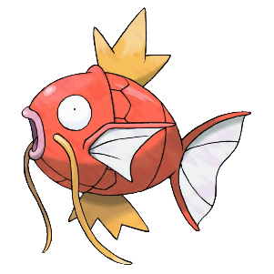The official starters:

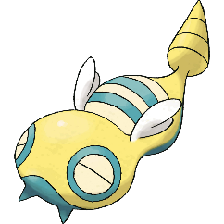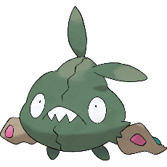

# Gym Leader

## Undefined

Type:

Gym: Corrupted Pokémon Gym

Description:

Undefined is a corrupted Gym Leader. There is no way the player can understand it except if it knows how to decode it.

Speciality:

* All trainers will complain about errors they had using different code languages.
* The Gym Leader’s text will be crypted.
* The Gym Leader’s Pokemon will uses randomized color.
* The Gym Leader will use a Legendary Pokemon named “MissingNo”.
* The Gym battle theme will be very buggy.

## Swift

Type:

Gym: Apple Store

Description:

Swift is an Apple Store manager. He thinks Apple is the best OS and Android is inferior in every way. Your typical Apple normie.

Speciality:

* All the trainers are employees of the Apple Store.
* There are non-trainer NPC in the Gym looking to buy Apple Product (They are saying normies stuff).

## Pascal

## Ruby

Type:

Gym: Traditional Shrine

Description:

Ruby is a Japanese gym leader. He is the owner of the shrine.

Speciality:

* All the Pokémon’s name will be in Japanese.
* Luka (Stein’s gate) will be a trainer in the Gym

## Shell

## Crystal

## Python

## Dart

# Cities

## Plank Town

Description: Plank Town is a small undeveloped town stuck in 1950. Peoples here are very old school. You character want to get out of this boomer town.

Story: Your dad wants you to get out of this city and gives you a pokémon

Inspiration: Plankalkül is the first high-level programming language.

Characteristics:

* 4 houses
* 7 NPCS (2 inside 5 outside)

Once you get your first badge, if you talk to the fisherman, he will give you an old rod.

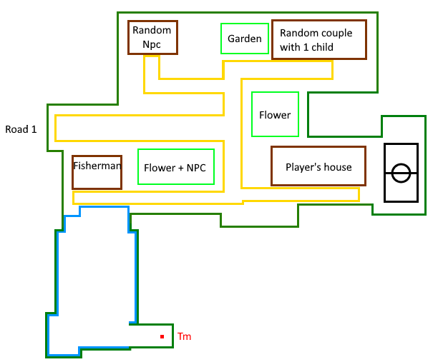

## City 2

Description: City is a small city with a bit more advanced technology than Plank Town. There is a Pokécenter.

Story:

Inspiration:

Characteristics:

Once you get your first badge, if you talk to the fisherman, he will give you an old rod.

# Artificial Intelligence

## Wild Pokémon

If the player’s Pokemon has 10 % or less, the Wild Pokemon will try to use a priority move that deal damage. If it does not have any priority move, he will try to use a damaging move. If it does not have any of those, it will simply do a random between 1 and the number of moves it has.